BEC Site Identification and Interpretation for the Cariboo Forest Region

OBJECTIVES
- Review how to apply biogeoclimatic ecosystem classification (BEC) to identify and interpret sites in the IDFdk3 variant near Knife Creek in the Alex Fraser Research Forest in the Cariboo Forest Region

INTRODUCTION
- The biogeoclimatic ecosystem classification system is the foundation for many site-level forest management decisions made in British Columbia. Recall, you use site environmental and vegetation data, and region-specific field guides to identify and interpret site series, the basis of many management decisions.

Review of the Site IDENTIFICATION Procedure FOr INTERIOR FORESTS
1. Climate Classification: Identifying Biogeoclimatic Units
Each biogeoclimatic unit has its own edatopic grid (used for site classification) and vegetation table (used for vegetation classification to support site classification). Once you have determined the biogeoclimatic unit for your study area, you can refer to these tools to classify the site association and site series.

You would need to acquire and use maps depicting BEC units and determine the likely range of options for your study area. Before going to the field you would access the appropriate the field guide and lookup the appropriate descriptions, vegetation tables and edatopic grids in the field guide. Maps and field guides will be provided at Fall Camp.

2. Site Classification: Identifying Site Series
This flow chart has been modified to show how to determine site series for study sites using environmental and vegetation data that you will collect in the field. You will need to describe your field site: external (topographic attributes) and internal (soil pit organic and mineral horizons) soil properties and the vegetation, including canopy composition and structure, plus identifying indicator species and estimating their cover.
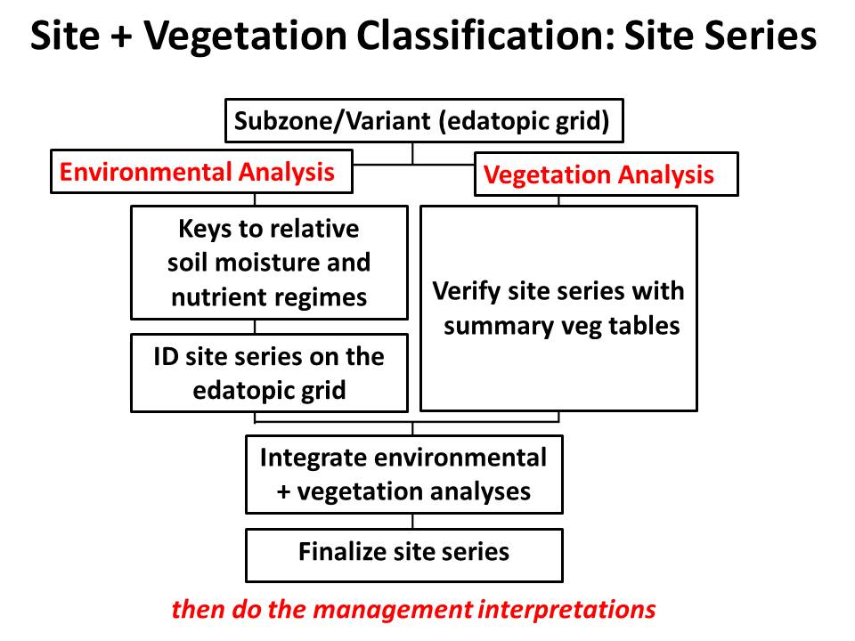 | Environmental Analysis  Based on the physiographic and soil properties on the site assessment forms, use the keys in the field guide to estimate RSMR, ASMR and SNR.  In the field guide, locate the edatopic grid that is specific to the IDFdk3. Use the edatopic grid to determine where the estimated RMR and SNR intersect to identify the site series.  Verify with the vegetation analysis using the vegetation summary tables.

Vegetation summary tables
Compare the vegetation cover data from your sample site to the standard summary tables (provided at Fall Camp) to select the best match and estimate site series. Most site series do not have exclusive plants, so relative abundances and presence/absence of groups of plants are used to distinguish site series.

Recall: Summary tables list species by structural layer (rows = trees at top to mosses at bottom). Site series are in columns arranged from driest (left) to wettest (right). Species prominence values are a combination of cover and frequency and are represented by the length of the black bars in the tables.

3. Integrating Environmental and Vegetation Analyses
Ideally, site identification from environmental and vegetation analyses will coincide to finalize the site series.
If vegetation analysis gives a wide-ranging or variable result, emphasize the environmental analysis. Recall, vegetation can vary with disturbance or human impacts making it atypical.
If vegetation analysis gives a strong, distinct result that differs from environmental analysis, look closely to explain the discrepancy.
If neither vegetation nor environmental analyses provide a clear identification, check if the area is in a climatic transition and consider the edatopic grids and vegetation tables for adjacent biogeoclimatic units.
Table 1. Summary of the site series identification for four sites in the Knife Creek block of the Alex Fraser Research Forest located in the IDFdk3 subzone of the Cariboo Forest Region, British Columbia.
Site | Site Assessment |  |  |  | Vegetation Assessment | FINAL  Site Series Code  and Name
 | RSMR | ASMR | SNR | Site Series | Site Series from
 |  |  |  |  | Summary Tables
1
2
3
4

Table 2. Management interpretations for four sites in the IDFdk3 variation of the Cariboo Forest Region.
Site | Site Series | Ecologically adapted  tree species (codes) | Principle site factors limiting tree establishment and growth
 |  |  | No/limited canopy | Canopy present
1

2

3

4

Thought Questions.
1. Consider the differences in the environmental conditions among the four sites. How do these explain the limiting factors for tree establishment and growth at each site?
2. For the zonal site only, what is the “vegetation potential and complex”? What does this term mean? (Hint review the section on Silvicultural Considerations in the field guide).

